The Spanish economy and Climate Change: An Input-Output analysis

By JD and Lucien
To measure our success in fighting climate change, we must look at one primary figure: the volume of GHG emissions in the atmosphere. It turns out that the extent to which production contributes every year to such a volume of emissions depends greatly on its sectoral composition. This is because technologies used across sectors vary widely. For example, cement manufacturing depends on carbon-intensive combustion technologies for heating and cooling, while the business services sector is driven primarily by human interaction, a naturally low-carbon technology.
This is why the economic implications of climate policy differ greatly across sectors – it is supposed to punish carbon-intensive sectors more severely. But, such sectoral implications do not only depend on the direct emissions during production: an activity like business services requires the construction sector to build offices made with cement, steel beams, glass, etc. So, understanding a given sector or firm’s vulnerability to climate policy is not only about how much it emits directly, but also about how much your much needed suppliers emit. In fact, corporate reporting standards aspire to require disclosure across three categories: Scope 1 (direct emissions), Scope 2 (indirect emissions from purchased electricity), and Scope 3 (all other emissions within the value chain, both upstream and downstream).
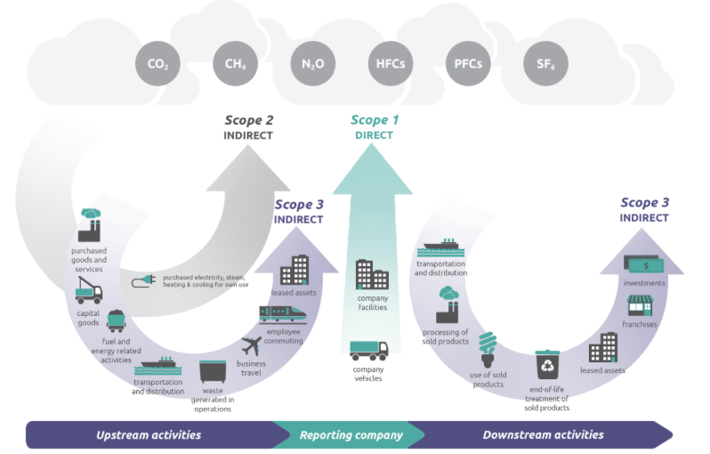
Source: U.S Environmental Protection Agency (EPA). Emissions by Scope inventory guidance
The Data
A useful tool to analyze direct and indirect emissions across sectors are Input-Output tables. Understanding these at a global level gets unnecessarily complicated, so let's focus on the Spanish economy.
Input-Output tables contain the output produced by each sector, as well as the inputs that each sector buys from other sectors. They also contain data on consumption, investment, government spending, and net exports, but we won’t need that for this exercise. Therefore, the table of interest looks as follows:
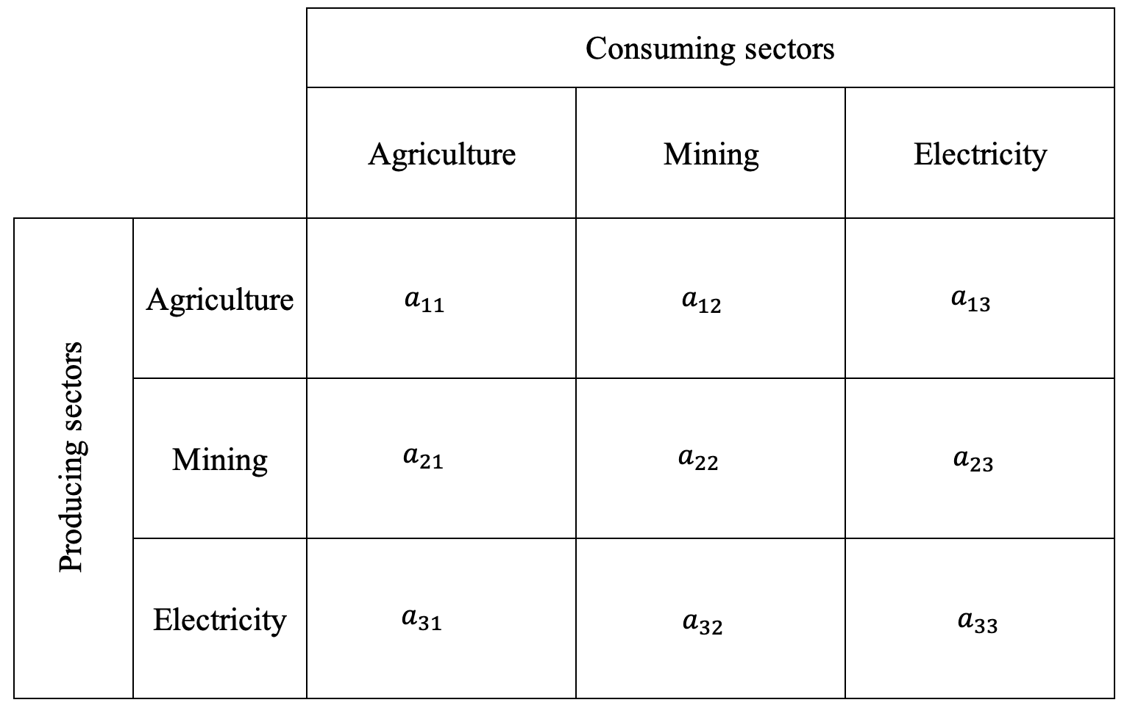
Source: Input-Output table. Own elaboration

The rows correspond to the producing sectors, and columns to the consuming sectors. Therefore, the agriculture row shows agricultural output sold to each consuming sector. The $a_{11}$ cell would therefore be the agricultural output sold to the agricultural sector, which is usually zero but sometimes positive: think of grain (output) used as seed (input) for the next planting season). The $a_{12}$cell would be the agricultural output sold to the mining sector, and so on.

EXIOBASE provides this table for 44 economies across 163 sectors. Moreover, EXIOBASE also provides the direct total GHG emissions for each of these country-sectors, so half of our work is already done (direct emissions). For the other half (indirect emissions), we will need to borrow a Nobel Prize winning idea…

The classical Leontief model

While the Input-Output table provides the "recipe" for production, that only tells us about the direct requirements. For example, we can see exactly how much electricity the agricultural sector purchases to produce its own output. However, for any sector, the chain does not stop there. The electricity suppliers need (their own inputs) fuel and infrastructure to operate. And fuel and infrastructure suppliers also need their own inputs to supply to electricity producers what they demand. Therefore, final demand for agricultural output triggers a whole chain of production across supplying sectors.
This is where the Nobel prize-winning Leontief Inverse model comes in. It accounts not only for the direct input requirements of a sector, but also for such a chain of production across supplying sectors. As a result, you end up with a matrix structured in the same way as the Input-Output table, but that shall be interpreted differently.
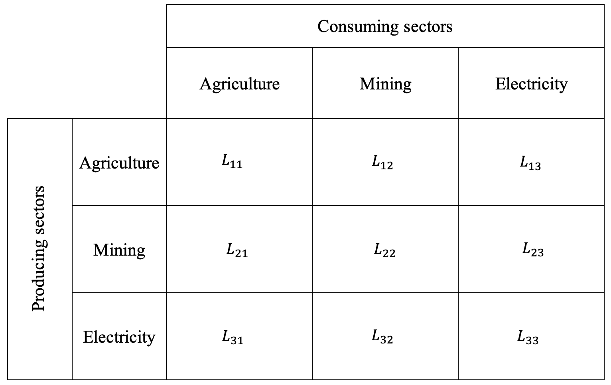
Source: Leontief Inverse matrix. Own elaboration
Now, $L_{31}$ does not only include the electricity consumed by the agricultural sector, but also the electricity needed by the suppliers of the electricity sector, and the electricity needed by the suppliers of the suppliers, and so on. Given this framework however, how do we translate all these upstream production requirements into emissions?
The Leontief environmental extension
To turn the Leontief matrix into an emissions map, you just need to multiply each cell by its corresponding producing sector’s emission intensity, which is just the sector’s total pollution divided by its total output. Essentially, you're taking the economic data and scaling it by a "pollution per dollar" rate to see the actual environmental impact. This calculation transforms the matrix from a web of economic transactions into a clear picture of total emissions required by each sector. Where, $L_{31}$ is the electricity input needed to produce agricultural output accounting for the full chain of supplying production, and $e_{elec}$ is the direct emission intensity of electricity providers.
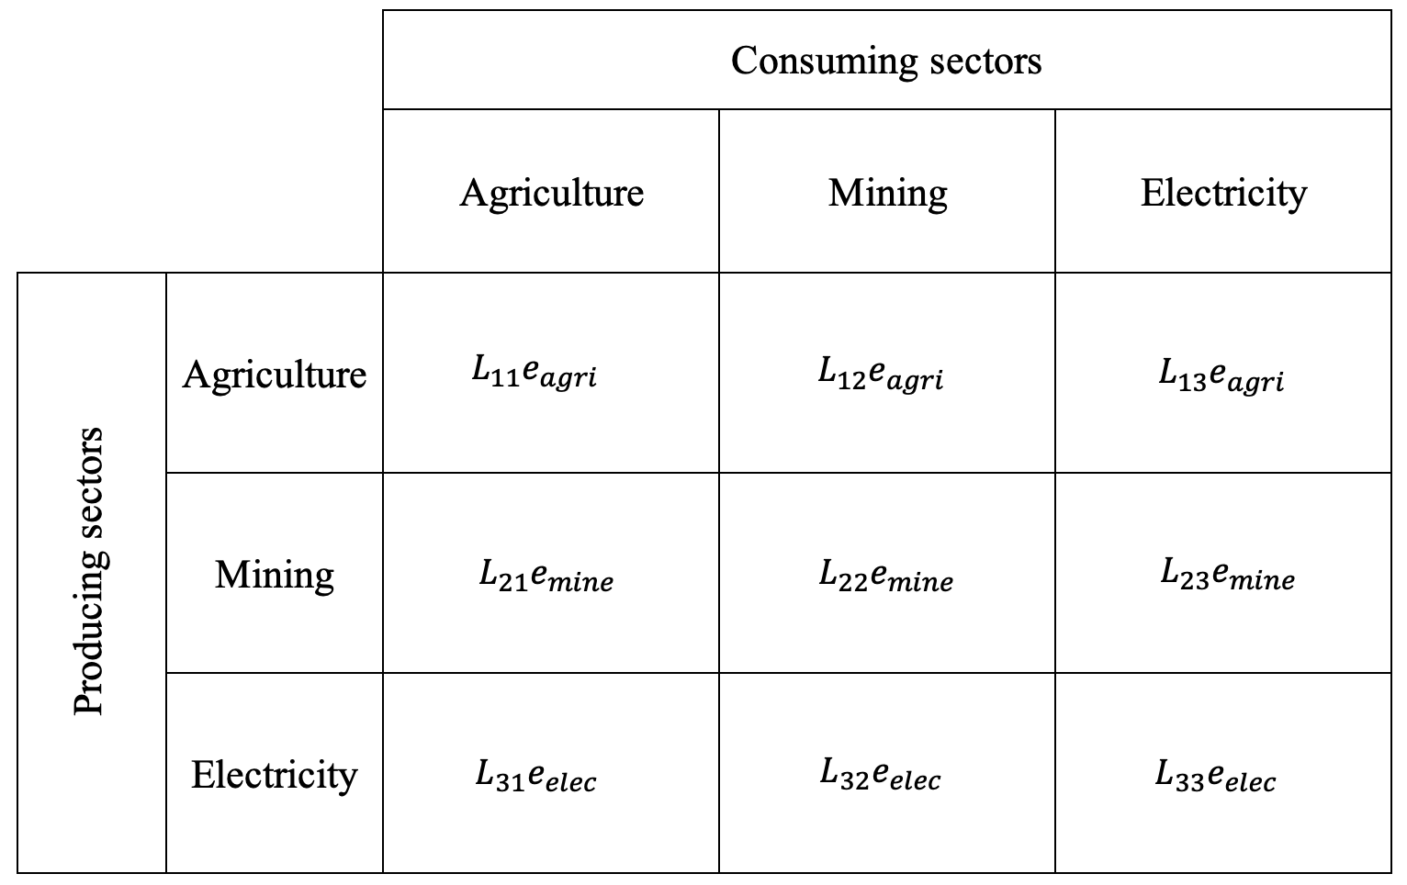
Source: Environmentally scaled Leontief Inverse matrix. Own elaboration.
It must be noted that there are two main limitations that come with this approach. First, the Leontief model only recovers the upstream production requirements, but it does not take into account the downstream chain of events shown by the last arrow on the right in Figure 1, missing a key area of Scope 3 emissions. The Leontief inverse does not track what happens to the agricultural products afterward. The crops may be processed into packaged foods, transported across countries, sold through retail chains, and ultimately consumed by households, each stage generating additional emissions that are not attributed back to the agricultural sector in the standard Leontief framework. Therefore, we account for Scope 1 and 2 emissions fully, and only a fraction of Scope 3 emissions.
Second, production technology is assumed to be fixed in this model, meaning the input expenditure shares and emission intensity of a given sector cannot change. In reality, sectors can adjust how much they spend on each input, for example, to reduce costs or respond to policy changes. However, in this case we are not simulating a counterfactual scenario, such as a carbon tax. Instead, we are estimating the emissions associated with each sector under current conditions, so this limitation is relatively minor.
The Results for the Spanish Economy
The uses of input-output matrices are broad. In this article, we focus on combining them with the emissions satellite account. Satellite accounts are supplementary accounts that sit alongside the national accounts and make it possible to analyze dimensions that GDP does not capture. They are linked to the same sectoral structure, so you can connect economic activity to things like tourism, ecosystem services, unpaid household work, water and nutrient use, and emissions. In that sense, they are a practical “Beyond GDP” tool: they keep the accounting backbone of national accounts, but extend it to variables that matter for welfare and sustainability.
There are also many ways to present and interpret the results. We keep the analysis simple, but still thorough. A first pass using total emissions will often just mirror the size of a sector, because producing more typically implies emitting more. To get a cleaner comparison across sectors, we standardize emissions by output, measuring emissions per euro of production. This shifts the focus from “who emits the most in total” to “who is most emissions-intensive,” which is the more relevant lens for understanding where decarbonization pressure will bite and where supply-chain exposure can be large even for sectors that look clean on Scope 1 alone.
Before turning to intensity, Figure X reports total output (as a proxy for GDP), employment, and emissions by sector in Spain. This gives a baseline sense of scale, satisfies your obvious curiosity of “who are the big players?”, and helps interpret the intensity results that follow: large sectors may dominate totals even if they are relatively clean per euro, while smaller sectors can look modest in aggregate but stand out once you account for emissions per unit of production.
[es_dashboard_tabs.html]
As shown in the figure above, real estate activities, hotels and restaurants, and construction are among the largest sectors in the Spanish economy. The first two are service-oriented, so their direct emissions tend to be relatively low. Construction, in contrast, is material and energy intensive, which is why it stands out on the emissions side and ranks as one of Spain’s highest-emitting sectors (see the Emissions tab in the dashboard).
One natural next step is to look at the composition of those emissions. This is where input-output matrices are useful: they help trace where the construction sector’s footprint actually originates. When a skyscraper is being built, the emissions you observe locally may not rise much at the construction site itself. Yet, as the “Emissions” tab shows, most of construction’s footprint sits in Scope 3 (over 70%). The obvious question is: which upstream sectors are driving it, and how far back does that chain go? To make that visible, we map the construction supply chain as a network at the end of this article.
For now, we go back to a fairer comparison across sectors: the emissions intensity tab in our dashboard. This section ranks sectors by emissions per euro of output. In 2022, Petroleum refinery, construction, and manufacture of gas are the top emitter sectors of the economy. However, when looking at emission intensities by sector, electricity by coal and petroleum, and cattle farming comes as the top three industries, emitting about 28kg, 14kg and 13kg of CO2e per EUR of output. If we take into account the social cost of carbon (185 EUR per ton, ie, 0.185 EUR per kg), these sectors are producing more harm than benefits (5.85 EUR of externalities per 1 EUR of production).

In principle, the same logic lets us compute an “implied climate damage” for every industry and see where external costs are likely to dwarf market value. But this is strictly back-of-the-envelope. The social cost of carbon is uncertain and sensitive to assumptions. Emissions intensities depend on accounting boundaries and on the input-output structure, and our Scope 3 coverage is incomplete. Output measured in euros is not a welfare metric, and this calculation ignores benefits, distributional effects, abatement options, and other externalities beyond CO2e. Used properly, it is a screening tool to flag hotspots, not a definitive cost-benefit statement.

[es_scc_damage_interactive]

Takeaways

Aquí nos tenemos que poner de acuerdo en los principales mensajes que se pueden extraer de los resultados así como las limitaciones del análisis empleado.

[scope1_center_2d_with_year_slider]

